**Curriculum Vita**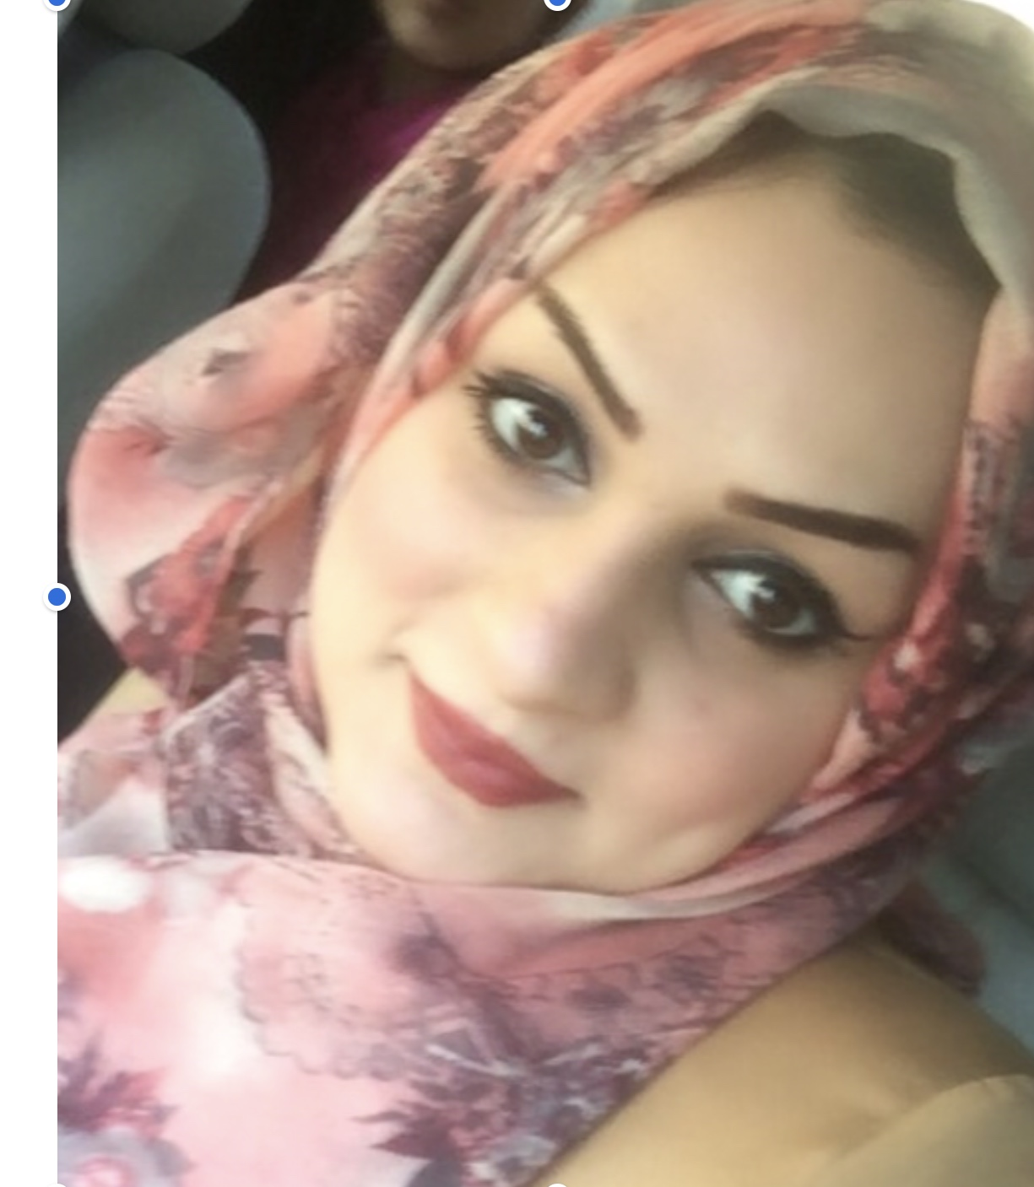

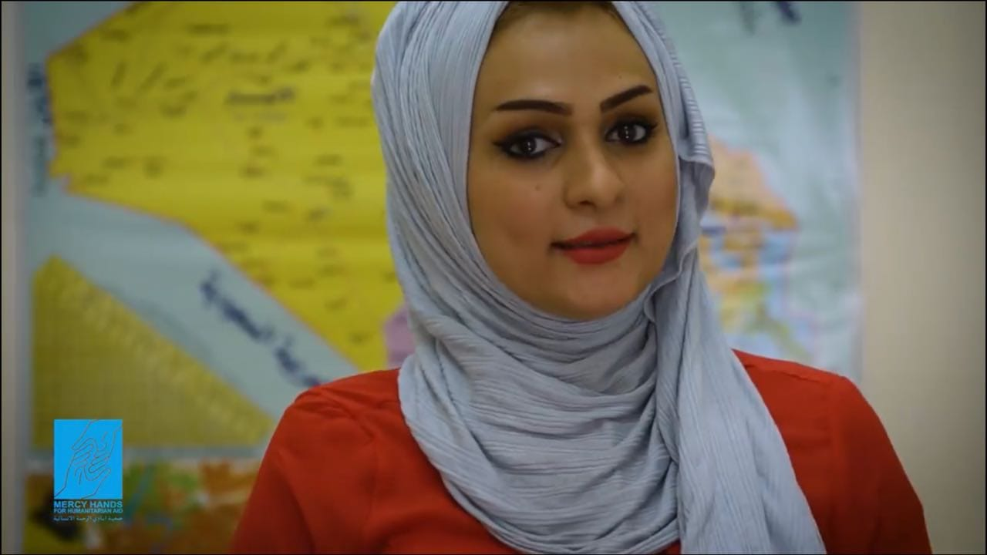

**Full Name** :    **Namees Mohammed salah**

**Date of Birth:** 1/8/1992

**Place of Birth:** Iraq , Baghdad

**Gender:**                Famale

**Nationality:**Iraqi

**Full Address:**Iraq, Baghdad ,alsaydia

**Advanced English:** Speaking, Reading & Writing

**Computer Skills: Sql oracle 12 c. work on office Programs**

**A2A application Iraq airways**

**C language**

**JAVA**

**HTML**

**PHP**

**visual basicand visual studio2010**

**sql server,database**

**Summer training in Communications, and internet.**

**Last job in:**

**#1 Reporting translator officer in mercy hands for humanitarian aid to sending for international donor, assistant manager in all work plans at legal project for vulnerable persons in central and southern of Iraq including Baghdad,Basra and Diyala teams as Statelessness ,follow up teams work flow and their accomplishments, manage of E-Survey system as well as reporting**

**#2 Earthlink (ISP) software server**

**#3 Establishing a program for archiving by using visual studio and SQL server 2010 in VB languages** **that is using in School,Banking,company,which is using ARCH. system**

**#5 Manage four page by internet**

**#6 HR in Germany center**

**# Data base officer IDPs/Statlessness project for MH**

**#mobile/field officer as well as coordinator to provide assistance for the under poverty line families (Alsader City)**

**#database orphans officer in al-Ber alraheem foundation**

**#Manage the Feedback & complaints line for Baghdad office reporting registering and following up with the teams on the closure of complaints also I had this accountability work position in my previous job…**

**Phone number:07707101029**

**HINT" Recognition certificate granted by MH administrator manager shown below"**

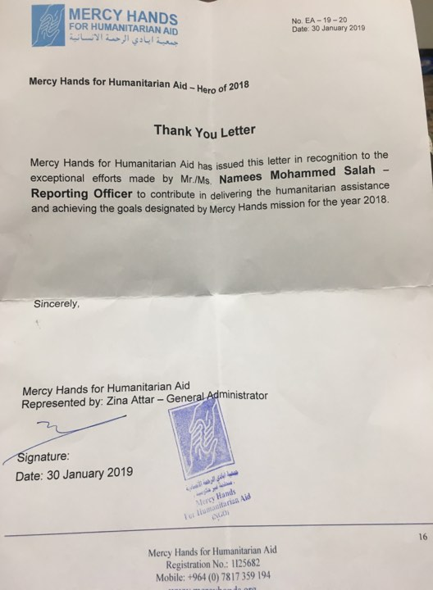

**Professional reference 1: Shashank Chaun -manager for protection programs**

**At mercy hands for humanitarian aid**

**E-mail** [**Shashankchaun@mercyhands.org**](mailto:Shashankchaun@mercyhands.org)

**Phone num.+964 774 045 1681**

**Professional reference2: zena alattar- general administrator manager**

**For mercy-hands for humanitarian aid**

**Phone num. +964 770 662 4003**

